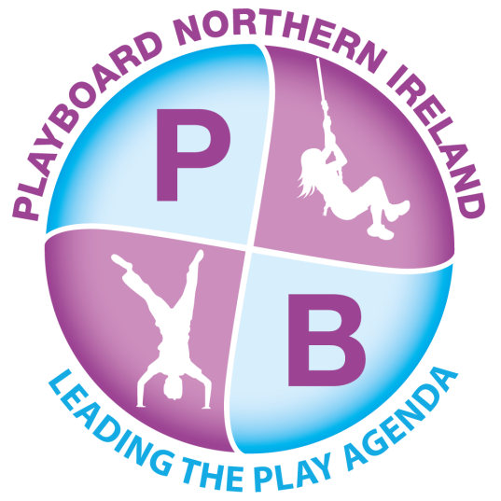

PlayBoard NI

TRUSTEE

Application Form

Please complete this application form using type no bigger than font 12 or black ink.
All sections of the form must be completed and be legible.
Non-completion of any section of the form may result in rejection of your application.
A continuation sheet can be used unless otherwise stated.
Personal Details

Title: (Mr, Mrs, Ms, Miss, Dr etc)
Forenames:
Preferred Name:
Surname:
Home telephone number:
Mobile telephone number:
Preferred contact telephone number:
Email address:
Home address:
Home address continued:
Town:
County:
Postcode:

Please indicate which role you are interested in:

PlayBoard Trustee |  | Chair |  | Vice Chair

SECTION 1: GENERAL DETAILS

a) Are you related to any employee or Board member of PlayBoard?
YES / NO [If YES, please state who and the relationship below]

SECTION 2: EDUCATION AND TRAINING
List details of any professional/vocational qualifications or training you have successfully achieved in REVERSE order starting with most recent first.

Year | Name of course or qualification achieved

Section 3: EMPLOYMENT

Current or most recent employment details [if applicable]
Name of Employer

Position Held

Date Current Employment Started
Main Duties:

Section 3: EMPLOYMENT [CONTINUED]:

Outline previous full-time / part-time employment history
for the 10 years before your current employment [if applicable].
Start with the most recent and work backwards (do not include your present position).

Name of employer | Position held and main duties

Section 4: Knowledge & Experience

Please outline your experience in the following areas:

4.1 Committee work

4.2 Experience advocating and negotiating on behalf of others

4.3 Knowledge of the policy framework in which the voluntary children and Young People’s sector operate

Section 5: Areas of Knowledge & Experience

5.1 Tell us about the knowledge, skills or experience you have that would be relevant to the position as a member of PlayBoard’s Board of Directors in one or more of the following areas?
- Governance
- Finance
- HR
- Play Delivery or Development
- Minority Ethnic Issues
- Media & Marketing
- Public Sector Service
- Primary Education
- Third Sector
- Childcare
- Youthwork
- Business Development
- Special Educational Needs

Section 6: Additional information

6.1 Tell us about any additional information that you feel is relevant to becoming a Trustee of PlayBoard.

Section 7: Reasonable Adjustments
Do you require any reasonable adjustments to participate in the recruitment and selection process or, if appointed, to undertake the duties of a Trustee? If yes, please provide details of the adjustments required.

The Disability Discrimination Act 1995 defines a person as having a disability if he or she has, or has had a physical or mental impairment which has a substantial and long-term adverse effect on his or her ability to carry out normal day-to-day activities.

Restrictions on Employment or Holding a Trustee Position
Disclosures
We ask that candidates disclose any information about their personal or professional life which in the Board’s perception could bring PlayBoard into disrepute, including removals from previous governance roles, current or previous membership of organisations which may conflict with the aims, principles and values of the organisation, or behaviour which might be seen to undermine public confidence and trust.

Candidates must also disclose if they have been convicted of a crime which debars them from acting as a company director, or they are an undischarged bankrupt or disqualified to act as a company director.

Candidates must disclose any information which could give rise to a perception of conflict of interest with their role as a PlayBoard Board Member.

Any disclosures will not necessarily result in an inability to serve on the Board.
Are there any restrictions to you working in the UK or holding a Trustee position? Yes No
If yes, please provide details: Continue on a separate sheet if necessary;

Data Protection

PlayBoard NI will process personal information provided as part of the recruitment and selection process in accordance with applicable UK data protection legislation, including the UK General Data Protection Regulation and the Data Protection Act 2018. PlayBoard will not disclose, or share, personal information supplied by you with any third-party organisation without your consent unless we are legally obligated to do so.

Declaration of Eligibility to be a Trustee and Company Director

I declare that:
- I am over age 16.
- I am not undischarged bankrupt.
- I have not previously been removed from trusteeship of a charity by a Court or the Charity Commission.
- I am not under a disqualification order under the Company Directors’ Disqualification Act 1986.
- I have not been convicted of an offence involving deception or dishonesty (unless the conviction is spent).
- I am, in the light of the above, not disqualified by HMRC or the Charity Commission from acting as a Charity Trustee.
- I undertake to fulfil my responsibilities and duties as a Charity Trustee and Company Director of PlayBoard in good faith and in accordance with the law.
Please give details of any business or other interests or any personal connections which, if you are appointed, could be misconstrued or cause embarrassment to PlayBoard. These could include financial interests or share ownership, active connections with a field of expertise in which the organisation works, Directorship (of charities, organisations, companies) and their activities, associations or employment of a partner or friend in the particular field in which PlayBoard operates.
Any potential conflicts of interest detailed here will not prevent you going forward to interview but may, if appropriate, be explored with you during your interview to establish how you would address the issue(s) should you be successful in your application.

With regard to your voluntary service as Trustee on the PlayBoard Board of the Directors, will you have any of the following potential conflict of interest to report:

- I am affiliated to another charity?

- Affiliated to any vendor, supplier, or any other party providing or bidding for providing services, having a direct or indirect interest in any business transaction(s), agreement and investment with PlayBoard?

- Having any business dealings or transaction with a vendor, supplier or any other party which could result in benefit to me?

- I or person(s) I have affiliation with have interest in purchasing services from PlayBoard?

- Affiliated to any staff of PlayBoard?

- Affiliated person(s) is involved is a party to or have an interest in any pending legal proceedings involving PlayBoard?

Reading the above list do you have you any conflicts of interest – Yes / No

If yes, please detail: Please elaborate on the potential conflict arising from the above situation with regards to the transaction concerned (e.g. nature of service/ transaction, if affiliated person involved, the identity of the affiliated person and your relationship with that person):

Affiliated refers to the following: Spouse, domestic partner, child, mother, father, brother or sister or close associates; any corporation, business or non-profit organisation of which you are serve as staff, officer, board member, partner, participate in management or are employed by; any trust or other estate in which you have a substantial interest or as to which you serve as a trustee or in a similar capacity.

I hereby declare that to the best of my knowledge, all the information given by me is correct.

Signature:

Date:

Please note that if it is subsequently found that any of the above statements are found to be false you could be disqualified from being a Director/Trustee of PlayBoard.

CANVASSING WILL DISQUALIFY
Please ensure that you have completed all relevant parts of this application form as only applications containing the information sought will be considered.

The information in this application form will be held securely both manually and electronically on PlayBoard’s secure network in accordance with current Data Protection legislation. We will treat the information given in this application as confidential however applicants are advised that legal processes may require us to disclose the form to certain statutory bodies.

Declaration
I hereby declare that:
- The statements contained in this application are, to the best of my knowledge true and correct; I agree that any misrepresentation by me will lead to the withdrawal of any offer to become a Trustee.
- I understand that, if appointed, details of my appointment as a Trustee and Company Director will be recorded on the relevant public registers and may be published on PlayBoard NI’s website and in other organisational materials, in accordance with applicable legal and regulatory requirements. We reserve the right to verify the information you have provided and seek information from other sources.
- I understand that, if shortlisted or appointed, PlayBoard NI may undertake appropriate checks to verify my identity, qualifications, references, eligibility to act as a Trustee and Company Director, and any other information relevant to my suitability for the role.
- I understand that, if appointed as a Trustee and Company Director of PlayBoard NI, I will be required to complete identity verification with Companies House and provide my Companies House personal code as required. I understand that my appointment cannot be completed unless the relevant Companies House identity verification requirements have been satisfied.

Signature: |  | Date:

Please email or post the completed application form marked:
Board Recruitment private & confidential
by Monday 14th September 2026 to:

Email to: Lauren.Robinson@playboard.co.uk

Post to: Lauren Robinson
Director of Corporate Services & Finance
Board Recruitment
PlayBoard NI
7 Crescent Gardens
Belfast
BT7 1NS

